EXPERIMENT-7
Name: PERIYA NAYAGAM M Roll no. : 240701382
Title
Development of Low-Fidelity Prototype for a Banking Application using Pencil Project
Objective
To design and develop a low-fidelity prototype for a mobile banking application and convert it into digital wireframes using Pencil Project.
Description
This experiment focuses on creating a basic banking application interface using low-fidelity design techniques. Initially, paper prototypes were created to visualize the structure of the application. These designs were then converted into digital wireframes using Pencil Project.
The application includes essential banking functionalities such as login, account dashboard, money transfer, and transaction history.
Modules Designed
1. Login Screen
- Allows users to enter username and password
- Includes a login button
- Acts as the entry point of the application
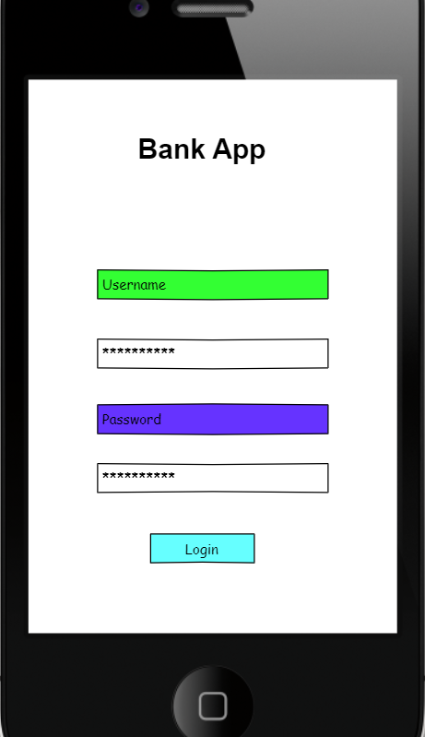

2. Dashboard Screen
- Displays welcome message
- Shows account balance
- Provides navigation options:
  - Send Money
  - Transactions
  - Profile
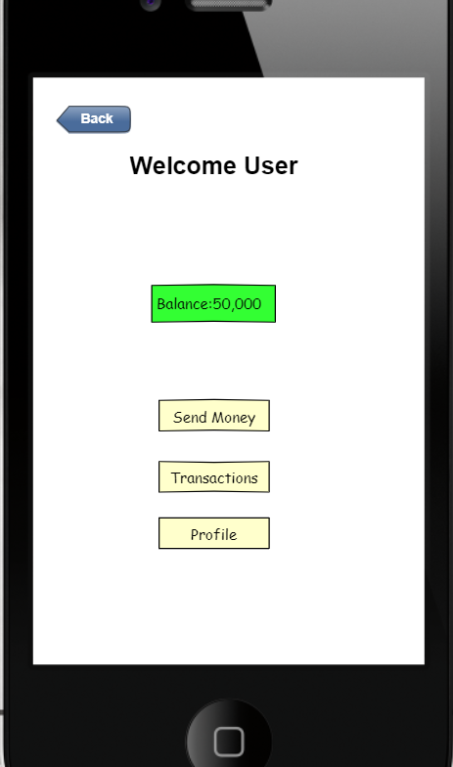

3. Send Money Screen
- Allows users to transfer money
- Inputs:
  - Account Number
  - Amount
- Includes a send button
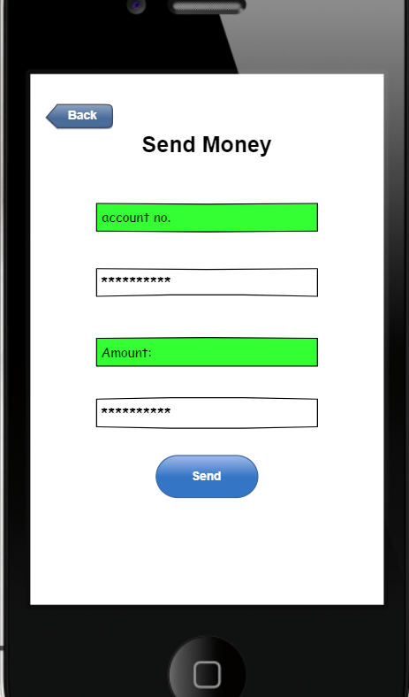

4. Transactions Screen
- Displays transaction history
- Shows details of previous transactions
- Helps users track spending
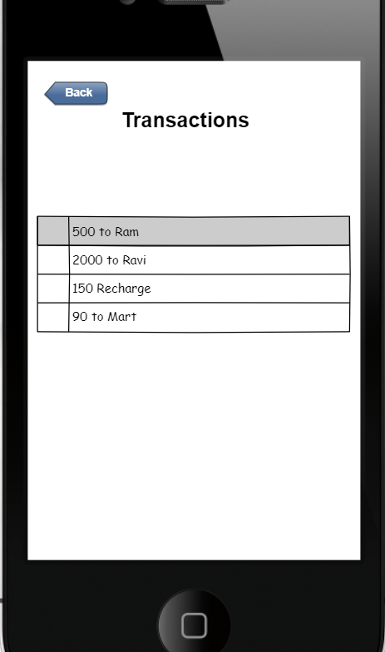
5. Profile Screen
- Displays user personal information such as name, phone number, and email
- Allows users to view and manage their account details
- Provides option to update basic profile information
- Includes a logout button for secure exit
- Helps in maintaining user account settings and preferences
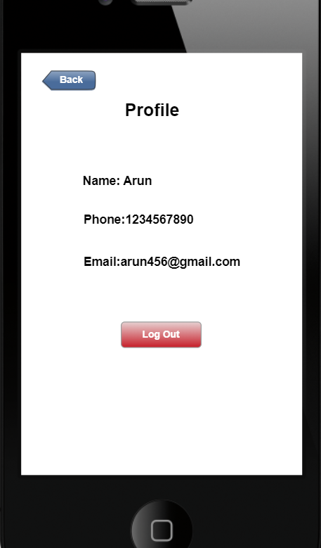
Procedure
- Identified the main features required for a banking application
- Created rough sketches of each screen on paper
- Opened Pencil Project and created a new document
- Selected mobile UI templates
- Designed the following screens:
  - Login Screen
  - Dashboard Screen
  - Send Money Screen
  - Transactions Screen
- Used shapes, text, and input fields to build layouts
- Arranged elements properly for clarity
- Exported the wireframes as images/PDF

Result
The low-fidelity prototype of the banking application was successfully created. The wireframes clearly represent the structure and flow of the application.
Conclusion
The experiment helped in understanding the importance of wireframing in application development. Low-fidelity prototypes are useful for planning layout, user flow, and functionality before actual development.

